**YEAR 11 GENERAL SCIENCE IN PRACTICE**

**Wheels in Motion**

Task Four: Movie Stunts and Car Jumps PROJECT (15%)

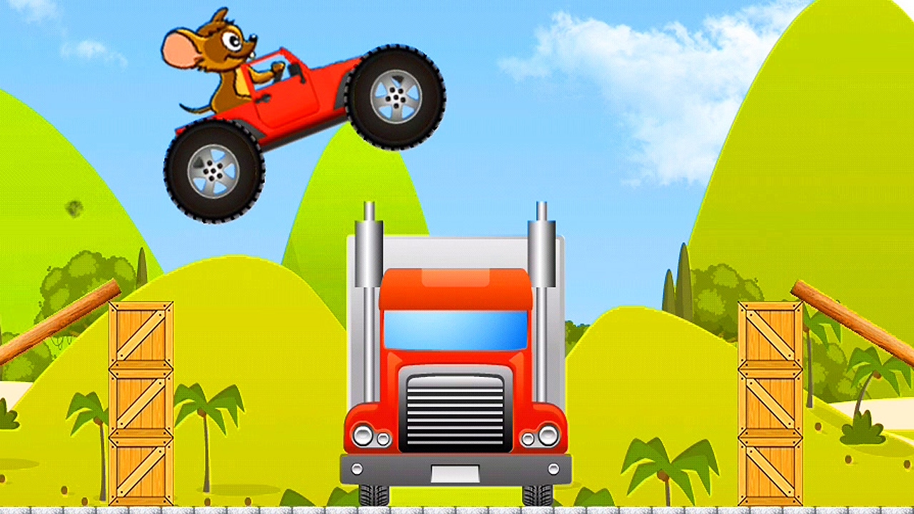

PROJECT JOURNAL

Name: _____________________________________________

**Contents Page**

|  |  |
| --- | --- |
| Page # | Description |
|  | Task 4: Movie Stunts and Car Jumps |
|  |  |
|  |  |
|  |  |
|  |  |
|  |  |
|  |  |
|  |  |
|  |  |
|  |  |
|  |  |
|  |  |
|  |  |
|  |  |

**YEAR 11 GENERAL SCIENCE IN PRACTICE**

**Wheels in Motion**

**Task 4: Movie Stunts PROJECT (15%)**

This **PROJECT** will take **8 HOURS** to complete in class.

**Conditions:**

This task has a number of parts:

Part A: Research a claim

Part B: Draft infographic

Part C: Produce final infographic

This task will be completed individually.

This task will be completed and submitted by the end of Week 15 **DUE DATE:**

**Task:**

Select and explore a movie car stunt to see if it defies the Laws of Physics. You are required to analyse and synthesise information from AT LEAST TWO different sources to produce an infographic to explain the relevant scientific concepts involved in the stunt and its impact and/or influence on society.

**Examples of infographics can be found at:**

* [COVID-19 vs the Flu or Cold - Nextcare](https://nextcare.com/health-resources/covid-19-vs-the-flu-or-cold/)
* <https://www.slideshare.net/markmccrindle/australia-the-sporting-nation-infographic>

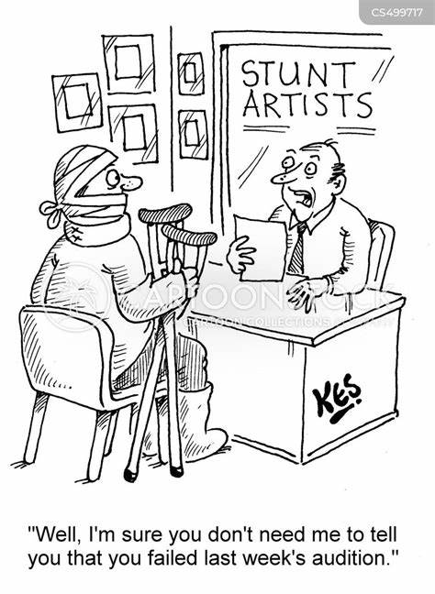

Your teacher will help by showing good and misleading examples of infographics.

The weighting for each component are as follows:

|  |  |
| --- | --- |
| Research | 30% |
| Draft project | 20% |
| Final project | 50% |

**Task weighting 15% for the year**

**Title: Movie stunts and car jumps**

Action movies are full of death defying and impressive stunts. “The Fast and The Furious” franchise of movies is famous for its car stunts. As the series has progressed the stunts seem to get more extreme and even defy the Laws of Physics.

In this task you will choose a particular movie or scene from a movie and analyse the car stunts for their physical merits responding to the claim **“Car stunts defy the Laws of Physics”**.

Your findings will be summarised in an infographic.

The infographic should be on a single sided A3 paper (or poster) and could be hand drawn or produced electronically. Make sure you reference AT LEAST TWO different sources of information to support your claims.

**To complete this task, you are required to:**

* Select a movie stunt scene to explore further
* Conduct research to:
  + Identify the Physics involved in the stunt
  + Describe the Physics concepts involved in the stunt, explaining how it defies or conforms to the Laws of Physics
  + Explain why the stunt should only be performed by trained stunt people
* Prepare a draft infographic responding to the claim
* Prepare the final infographic responding to the claim

**Check points:**

* Week 14 Start research and select a movie or scene to analyse
* Week 14 Conduct research and find at least two sources to support your claims
* Week 15 Submit draft infographic for feedback
* Week 15 Submit final infographic for marking

**Authentication strategies:**

The student will:

* Maintain a journal to document their progress
* Acknowledge all sources and references

The teacher will:

* Provide class time for task completion
* Monitor progress at specified check points
* Collect and annotate drafts

**List of movies with car stunts:**

* The Fast and The Furious franchise
* Mission Impossible franchise
* Speed
* Transporter franchise
* Disney’s Cars
* Baby Driver
* James Bond movie franchise

See more suggestions at:

* [Wildest Car Stunts in Film History (caranddriver.com)](https://www.caranddriver.com/features/g31978859/wildest-car-stunts-in-film-history/)



**Websites that analyse movie stunts:**

* [10 action sequences that defy the laws of physics | Den of Geek](https://www.denofgeek.com/movies/10-action-sequences-that-defy-the-laws-of-physics/)
* [Busting Favourite Hollywood Stunt Myth | TOP MOMENTS OF MYTHBUSTERS (youtube.com)](https://www.youtube.com/watch?v=j8-tJ7cYing)
* [Good and Bad Examples of Physics in Movies (youtube.com)](https://www.youtube.com/watch?v=ud592YKhePI)
* [Top 10 Stunts of All Time (youtube.com)](https://www.youtube.com/watch?v=oVm1qoGWGxk)

It would be easier to look at a scene that has already been analysed and use your own words to explain if it is realistic using your understanding of motion and Newton’s Laws.

You will still need to complete the research section of the Journal, as well as the final infographic.

Presenting your research as an infographic relies on good understanding of the concepts, as well as choosing graphics and diagrams that easily explain the Science.

Your teacher will show both good and misleading examples of infographics so you can decide how to present your findings.

**Part A: Background Research**

What are Newton’s Three Laws of Motion?

1. ______________________________________________________________________

________________________________________________________________________

2. ______________________________________________________________________

________________________________________________________________________

3. ______________________________________________________________________

________________________________________________________________________

Give an everyday example of these Laws:

1. ______________________________________________________________________

________________________________________________________________________

2. ______________________________________________________________________

________________________________________________________________________

3. ______________________________________________________________________

________________________________________________________________________

Explain how to calculate the speed, velocity and acceleration of an object. Include equations help with the explanation.

________________________________________________________________________

________________________________________________________________________

________________________________________________________________________

________________________________________________________________________

________________________________________________________________________

________________________________________________________________________

Choose a movie scene that contains a car stunt or similar. You will need to watch the scene a few times over to understand the sequence of events and accurately observe details that may happen very quickly.

|  |  |
| --- | --- |
| **Name of Movie** |  |
| **Year Released** |  |
| **Main Cast** |  |
| **Director** |  |
| **Country of Origin** |  |

What make and model car/vehicle is used?

________________________________________________________________________

________________________________________________________________________

What is the mass and maximum speed of the car/vehicle?

________________________________________________________________________

________________________________________________________________________

Link to video clip of scene (if available):

What scene have you chosen to explore? Describe the action sequence.

________________________________________________________________________

________________________________________________________________________

________________________________________________________________________

________________________________________________________________________

________________________________________________________________________

________________________________________________________________________

Make a note of any major movements, collisions or explosions in the scene.

________________________________________________________________________

________________________________________________________________________

________________________________________________________________________

Which of Newton’s Laws do you think apply to this scene? Explain your reasoning.

________________________________________________________________________

________________________________________________________________________

________________________________________________________________________

________________________________________________________________________

If possible, collect some quantitative data from the scene. This could involve measuring distances, timing events or estimating speeds.

Use the space below to make any calculations about speed or acceleration for the car/vehicle in the scene.

Is the stunt realistic? Why or why not?

________________________________________________________________________

________________________________________________________________________

________________________________________________________________________

________________________________________________________________________

________________________________________________________________________

________________________________________________________________________

If the stunt was not realistic, how was the scene done? (E.g. CGI)

________________________________________________________________________

________________________________________________________________________

________________________________________________________________________

________________________________________________________________________

Look for expert analysis or educational videos where physicists break down movie scenes. This can provide insights into how professionals approach the task and may highlight things that you hadn’t considered.

Be sure to record your references in the correct format.

**Part B: Infographics – Good vs Misleading**

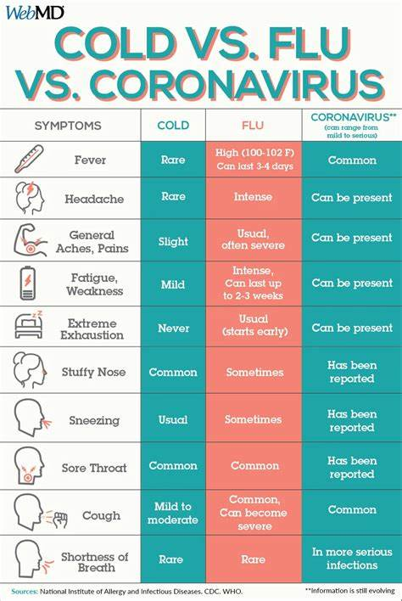

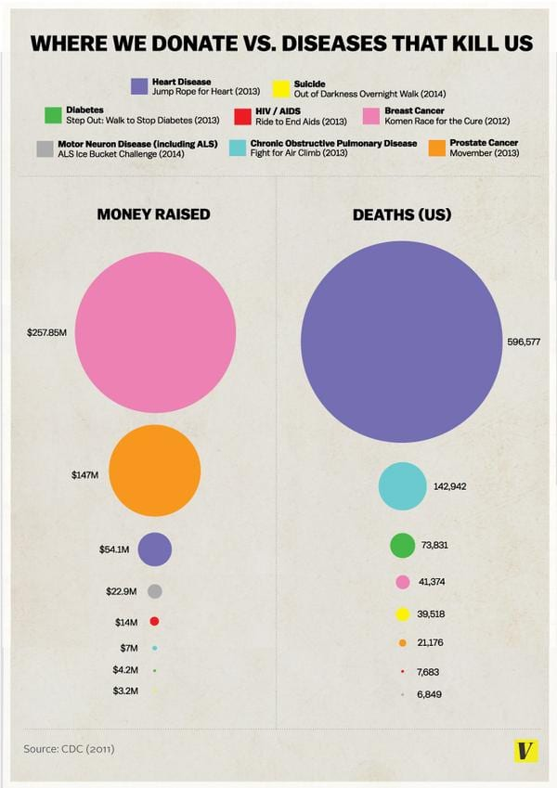

**What makes an Infographic Good or Misleading?**

|  |  |  |
| --- | --- | --- |
|  | **GOOD** | **MISLEADING** |
| **Design layout** |  |  |
| **Data visualisation** |  |  |
| **Context** |  |  |
| **Details on graphs** |  |  |
| **Colour** |  |  |
|  |  |  |

**How to Make an Infographic**

1) Understand your target audience

This will help you to decide what level of explanation your need, the amount of writing and type of pictures/diagrams you use.

2) Be clear with your goal

What message are you trying to get across? Stick to a single topic and send that message clearly.

3) Collect and choose relevant data/information

Make sure all the information you use for your calculations and explanations is accurately researched AND come from credible sources. If information is lacking, be sure to clearly state any assumptions or educated guess that you make.

4) Organise your information

Arrange your information in a logical way that tells a story from start to finish.

5) Simplify your message

Avoid clutter and focus on key points

6) Choose an infographic design to suit your message

Use an online website and template or design your own layout. Choose the right colours and fonts to enhance your message and make your infographic visually appealing and easy to read.

7) Use visuals that help with understanding your message

Graphs, maps, timelines, diagrams and photos will reinforce your message.

**More information and online infographic makers:**

* [How to Make an Infographic in Under 1 Hour (2024 Guide) - Venngage](https://venngage.com/blog/how-to-make-an-infographic-in-5-steps/)
* Canva
* VistaCreate
* Piktochart
* Venngage